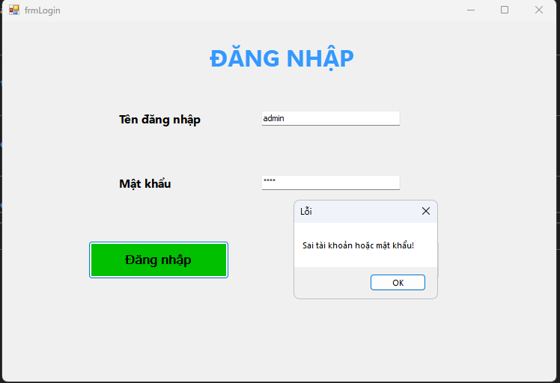

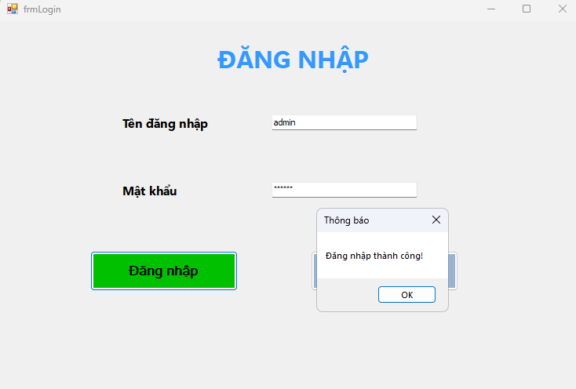

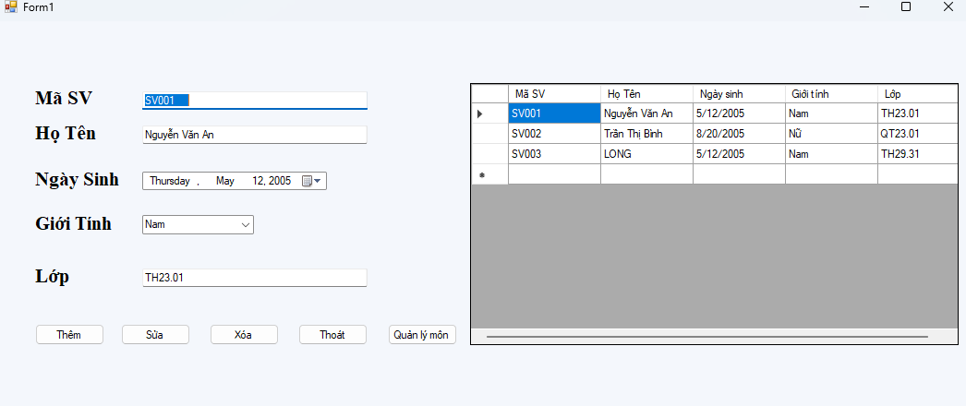

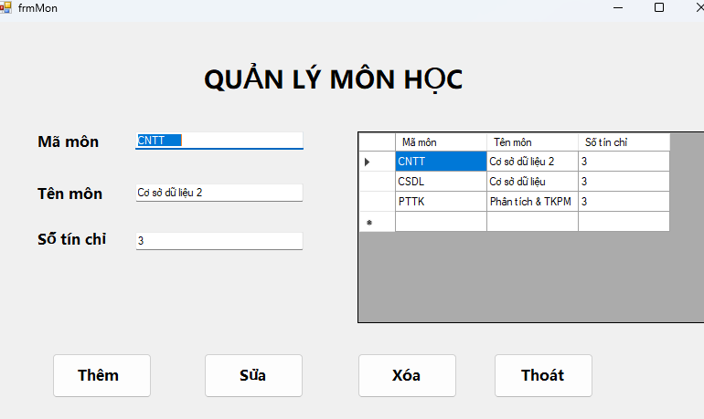

**Code đăng nhập**

Imports System.Data.SqlClient

Imports System.Configuration

Public Class frmLogin

Private ReadOnly connStr As String =

ConfigurationManager.ConnectionStrings("QLSV").ConnectionString

Private Sub btnLogin_Click(sender As Object, e As EventArgs) Handles btnLogin.Click

If String.IsNullOrWhiteSpace(txtUser.Text) OrElse String.IsNullOrWhiteSpace(txtPass.Text) Then

MessageBox.Show("Vui lòng nhập đầy đủ tài khoản và mật khẩu!", "Thông báo")

Return

End If

Using cn As New SqlConnection(connStr),

cmd As New SqlCommand("SELECT COUNT(*) FROM NGUOIDUNG WHERE UserName=@u AND Password=@p", cn)

cmd.Parameters.AddWithValue("@u", txtUser.Text.Trim())

cmd.Parameters.AddWithValue("@p", txtPass.Text.Trim())

cn.Open()

Dim count As Integer = CInt(cmd.ExecuteScalar())

If count > 0 Then

MessageBox.Show("Đăng nhập thành công!", "Thông báo")

Me.Hide()

Form1.Show()

Else

MessageBox.Show("Sai tài khoản hoặc mật khẩu!", "Lỗi")

End If

End Using

End Sub

Private Sub Label1_Click(sender As Object, e As EventArgs) Handles Label1.Click

End Sub

Private Sub btnThoat_Click(sender As Object, e As EventArgs) Handles btnThoat.Click

Application.Exit()

End Sub

Private Sub frmLogin_Load(sender As Object, e As EventArgs) Handles MyBase.Load

End Sub

End Class

**Code quản lý thông tin sinh viên**

Imports System.Data

Imports System.Configuration

Imports System.Data.SqlClient

Public Class Form1

Private ReadOnly connStr As String =

ConfigurationManager.ConnectionStrings("QLSV").ConnectionString

Private Sub Form1_Load(sender As Object, e As EventArgs) Handles MyBase.Load

cboGioiTinh.Items.Clear()

cboGioiTinh.Items.AddRange(New String() {"Nam", "Nữ"})

If cboGioiTinh.Items.Count > 0 Then cboGioiTinh.SelectedIndex = 0

LoadSinhVien()

End Sub

Private Sub LoadSinhVien()

Using cn As New SqlConnection(connStr),

da As New SqlDataAdapter("SELECT SV_ID, HoTen, NgaySinh, GioiTinh, LopID FROM SINHVIEN ORDER BY SV_ID", cn)

Dim tb As New DataTable()

da.Fill(tb)

dgvSinhVien.DataSource = tb

End Using

If dgvSinhVien.Columns.Contains("SV_ID") Then dgvSinhVien.Columns("SV_ID").HeaderText = "Mã SV"

If dgvSinhVien.Columns.Contains("HoTen") Then dgvSinhVien.Columns("HoTen").HeaderText = "Họ Tên"

If dgvSinhVien.Columns.Contains("NgaySinh") Then dgvSinhVien.Columns("NgaySinh").HeaderText = "Ngày sinh"

If dgvSinhVien.Columns.Contains("GioiTinh") Then dgvSinhVien.Columns("GioiTinh").HeaderText = "Giới tính"

If dgvSinhVien.Columns.Contains("LopID") Then dgvSinhVien.Columns("LopID").HeaderText = "Lớp"

End Sub

Private Sub ClearInputs()

txtMaSV.Clear()

txtHoTen.Clear()

dtpNgaySinh.Value = Date.Today

cboGioiTinh.SelectedIndex = 0

txtLop.Clear()

txtLop.Clear()

txtMaSV.Focus()

End Sub

Private Sub EnsureKhoaExists(khoaId As String, tenKhoa As String)

Using cn As New SqlConnection(connStr)

cn.Open()

Using chk As New SqlCommand("SELECT COUNT(*) FROM KHOA WHERE KhoaID=@id", cn)

chk.Parameters.AddWithValue("@id", khoaId.Trim())

Dim c As Integer = CInt(chk.ExecuteScalar())

If c = 0 Then

Using ins As New SqlCommand("INSERT INTO KHOA(KhoaID, TenKhoa) VALUES(@id,@ten)", cn)

ins.Parameters.AddWithValue("@id", khoaId.Trim())

ins.Parameters.AddWithValue("@ten", tenKhoa.Trim())

ins.ExecuteNonQuery()

End Using

End If

End Using

End Using

End Sub

Private Sub EnsureLopExists(lopId As String, tenLop As String)

If String.IsNullOrWhiteSpace(lopId) Then Throw New Exception("Mã lớp không được để trống.")

Dim defKhoa As String = "KHAC" ' đổi thành "CNTT" nếu bạn muốn

Dim tenDefKhoa As String = "Khác" ' đổi tên khoa mặc định nếu cần

EnsureKhoaExists(defKhoa, tenDefKhoa)

Using cn As New SqlConnection(connStr)

cn.Open()

Using checkCmd As New SqlCommand("SELECT COUNT(*) FROM LOP WHERE LopID=@id", cn)

checkCmd.Parameters.AddWithValue("@id", lopId.Trim())

Dim count As Integer = CInt(checkCmd.ExecuteScalar())

If count = 0 Then

Using insCmd As New SqlCommand(

"INSERT INTO LOP(LopID, TenLop, KhoaID) VALUES(@id,@ten,@khoa)", cn)

insCmd.Parameters.AddWithValue("@id", lopId.Trim())

insCmd.Parameters.AddWithValue("@ten", If(String.IsNullOrWhiteSpace(tenLop), lopId.Trim(), tenLop.Trim()))

insCmd.Parameters.AddWithValue("@khoa", defKhoa)

insCmd.ExecuteNonQuery()

End Using

End If

End Using

End Using

End Sub

Private Sub dgvSinhVien_SelectionChanged(sender As Object, e As EventArgs) Handles dgvSinhVien.SelectionChanged

If dgvSinhVien.CurrentRow Is Nothing Then Return

txtMaSV.Text = dgvSinhVien.CurrentRow.Cells("SV_ID").Value?.ToString()

txtHoTen.Text = dgvSinhVien.CurrentRow.Cells("HoTen").Value?.ToString()

Dim ns = dgvSinhVien.CurrentRow.Cells("NgaySinh").Value

If ns IsNot DBNull.Value AndAlso ns IsNot Nothing Then dtpNgaySinh.Value = CDate(ns)

cboGioiTinh.Text = dgvSinhVien.CurrentRow.Cells("GioiTinh").Value?.ToString()

txtLop.Text = dgvSinhVien.CurrentRow.Cells("LopID").Value?.ToString()

If String.IsNullOrWhiteSpace(txtLop.Text) AndAlso Not String.IsNullOrWhiteSpace(txtLop.Text) Then

txtLop.Text = txtLop.Text

End If

End Sub

Private Sub btnThem_Click(sender As Object, e As EventArgs) Handles btnThem.Click

If String.IsNullOrWhiteSpace(txtMaSV.Text) OrElse String.IsNullOrWhiteSpace(txtHoTen.Text) Then

MessageBox.Show("Nhập Mã SV và Họ Tên.")

Return

End If

If String.IsNullOrWhiteSpace(txtLop.Text) Then

MessageBox.Show("Nhập Mã lớp.")

Return

End If

EnsureLopExists(txtLop.Text.Trim(), txtLop.Text.Trim())

Using cn As New SqlConnection(connStr),

cmd As New SqlCommand("

INSERT INTO SINHVIEN(SV_ID,HoTen,NgaySinh,GioiTinh,LopID)

VALUES(@id,@ten,@ns,@gt,@lop)", cn)

cmd.Parameters.AddWithValue("@id", txtMaSV.Text.Trim())

cmd.Parameters.AddWithValue("@ten", txtHoTen.Text.Trim())

cmd.Parameters.AddWithValue("@ns", dtpNgaySinh.Value.Date)

cmd.Parameters.AddWithValue("@gt", cboGioiTinh.Text)

cmd.Parameters.AddWithValue("@lop", txtLop.Text.Trim())

cn.Open()

cmd.ExecuteNonQuery()

End Using

LoadSinhVien()

ClearInputs()

End Sub

Private Sub btnSua_Click(sender As Object, e As EventArgs) Handles btnSua.Click

If String.IsNullOrWhiteSpace(txtMaSV.Text) Then

MessageBox.Show("Chọn sinh viên cần sửa.")

Return

End If

If String.IsNullOrWhiteSpace(txtLop.Text) Then

MessageBox.Show("Nhập Mã lớp.")

Return

End If

EnsureLopExists(txtLop.Text.Trim(), txtLop.Text.Trim())

Using cn As New SqlConnection(connStr),

cmd As New SqlCommand("

UPDATE SINHVIEN

SET HoTen=@ten, NgaySinh=@ns, GioiTinh=@gt, LopID=@lop

WHERE SV_ID=@id", cn)

cmd.Parameters.AddWithValue("@ten", txtHoTen.Text.Trim())

cmd.Parameters.AddWithValue("@ns", dtpNgaySinh.Value.Date)

cmd.Parameters.AddWithValue("@gt", cboGioiTinh.Text)

cmd.Parameters.AddWithValue("@lop", txtLop.Text.Trim())

cmd.Parameters.AddWithValue("@id", txtMaSV.Text.Trim())

cn.Open()

Dim n = cmd.ExecuteNonQuery()

If n = 0 Then MessageBox.Show("Không tìm thấy Mã SV cần cập nhật.")

End Using

LoadSinhVien()

End Sub

Private Sub btnXoa_Click(sender As Object, e As EventArgs) Handles btnXoa.Click

If String.IsNullOrWhiteSpace(txtMaSV.Text) Then Return

If MessageBox.Show("Xóa sinh viên này?", "Xác nhận", MessageBoxButtons.YesNo) = DialogResult.No Then Return

Using cn As New SqlConnection(connStr),

cmd As New SqlCommand("DELETE FROM SINHVIEN WHERE SV_ID=@id", cn)

cmd.Parameters.AddWithValue("@id", txtMaSV.Text.Trim())

cn.Open()

cmd.ExecuteNonQuery()

End Using

LoadSinhVien()

ClearInputs()

End Sub

Private Sub btnThoat_Click(sender As Object, e As EventArgs) Handles btnThoat.Click

Close()

End Sub

Private Sub Form1_FormClosed(sender As Object, e As FormClosedEventArgs) Handles MyBase.FormClosed

Application.Exit()

End Sub

Private Sub btnMon_Click(sender As Object, e As EventArgs) Handles btnMon.Click

Dim f As New frmMon()

f.StartPosition = FormStartPosition.CenterScreen

Me.Hide()

f.ShowDialog()

Me.Close()

End Sub

End Class

**Code quản lý môn học**

Imports System.Data

Imports System.Configuration

Imports System.Data.SqlClient

Public Class frmMon

Private ReadOnly connStr As String =

ConfigurationManager.ConnectionStrings("QLSV").ConnectionString

Private Sub frmMon_Load(sender As Object, e As EventArgs) Handles MyBase.Load

LoadMon()

End Sub

Private Sub LoadMon()

Using cn As New SqlConnection(connStr),

da As New SqlDataAdapter("SELECT MonID, TenMon, SoTinChi FROM MON ORDER BY MonID", cn)

Dim tb As New DataTable()

da.Fill(tb)

dgvMon.DataSource = tb

End Using

If dgvMon.Columns.Contains("MonID") Then dgvMon.Columns("MonID").HeaderText = "Mã môn"

If dgvMon.Columns.Contains("TenMon") Then dgvMon.Columns("TenMon").HeaderText = "Tên môn"

If dgvMon.Columns.Contains("SoTinChi") Then dgvMon.Columns("SoTinChi").HeaderText = "Số tín chỉ"

End Sub

Private Sub ClearInputs()

txtMaMon.Clear()

txtTenMon.Clear()

txtSoTC.Clear()

txtMaMon.Focus()

End Sub

Private Sub dgvMon_SelectionChanged(sender As Object, e As EventArgs) Handles dgvMon.SelectionChanged

If dgvMon.CurrentRow Is Nothing Then Return

txtMaMon.Text = dgvMon.CurrentRow.Cells("MonID").Value?.ToString()

txtTenMon.Text = dgvMon.CurrentRow.Cells("TenMon").Value?.ToString()

txtSoTC.Text = dgvMon.CurrentRow.Cells("SoTinChi").Value?.ToString()

End Sub

Private Sub btnThemMon_Click(sender As Object, e As EventArgs) Handles btnThemMon.Click

If String.IsNullOrWhiteSpace(txtMaMon.Text) OrElse String.IsNullOrWhiteSpace(txtTenMon.Text) Then

MessageBox.Show("Nhập Mã môn và Tên môn.")

Return

End If

Dim stc As Integer

If Not Integer.TryParse(txtSoTC.Text.Trim(), stc) OrElse stc <= 0 Then

MessageBox.Show("Số tín chỉ phải là số > 0.")

Return

End If

Using cn As New SqlConnection(connStr),

cmd As New SqlCommand("INSERT INTO MON(MonID, TenMon, SoTinChi) VALUES(@id,@ten,@tc)", cn)

cmd.Parameters.AddWithValue("@id", txtMaMon.Text.Trim())

cmd.Parameters.AddWithValue("@ten", txtTenMon.Text.Trim())

cmd.Parameters.AddWithValue("@tc", stc)

cn.Open()

cmd.ExecuteNonQuery()

End Using

LoadMon()

ClearInputs()

End Sub

Private Sub btnSuaMon_Click(sender As Object, e As EventArgs) Handles btnSuaMon.Click

If String.IsNullOrWhiteSpace(txtMaMon.Text) Then

MessageBox.Show("Chọn môn cần sửa.")

Return

End If

Dim stc As Integer

If Not Integer.TryParse(txtSoTC.Text.Trim(), stc) OrElse stc <= 0 Then

MessageBox.Show("Số tín chỉ phải là số > 0.")

Return

End If

Using cn As New SqlConnection(connStr),

cmd As New SqlCommand("UPDATE MON SET TenMon=@ten, SoTinChi=@tc WHERE MonID=@id", cn)

cmd.Parameters.AddWithValue("@ten", txtTenMon.Text.Trim())

cmd.Parameters.AddWithValue("@tc", stc)

cmd.Parameters.AddWithValue("@id", txtMaMon.Text.Trim())

cn.Open()

Dim n = cmd.ExecuteNonQuery()

If n = 0 Then MessageBox.Show("Không tìm thấy Mã môn cần cập nhật.")

End Using

LoadMon()

End Sub

Private Sub btnXoaMon_Click(sender As Object, e As EventArgs) Handles btnXoaMon.Click

If String.IsNullOrWhiteSpace(txtMaMon.Text) Then Return

If MessageBox.Show("Xóa môn này?", "Xác nhận", MessageBoxButtons.YesNo) = DialogResult.No Then Return

Using cn As New SqlConnection(connStr),

cmd As New SqlCommand("DELETE FROM MON WHERE MonID=@id", cn)

cmd.Parameters.AddWithValue("@id", txtMaMon.Text.Trim())

cn.Open()

cmd.ExecuteNonQuery()

End Using

LoadMon()

ClearInputs()

End Sub

Private Sub btnThoatMon_Click(sender As Object, e As EventArgs) Handles btnThoatMon.Click

Close()

End Sub

End Class